

**UNIVERSITY OF GHANA**

(All rights reserved)

**Course Code and Title:** CPEN 103 -Computer Engineering Innovations

**Course Instructor:** Isaac Adjaye Aboagye, PhD

**FACE DETECTION AND RECOGNITION USING RASPBERRY PI**

**Group 7**

**Members**

Boniface Delali Dakey-10969344

Evans Acheampong- 10987644

Edward Acquah 10986982

Eyram Ahiator-10987509

Rapheal Kuayi-10970285

Delchris Daniels-10980292

Prince Charles Oheneba-Nkyi 10956252

**ABSTRACT:**

In today’s world, face recognition is an important part of the purpose of security and surveillance. Hence there is a need for an efficient and effective system. Face recognition is a fast-growing and challenging area in the field of computer vision and real-time applications. A lot of techniques and algorithms are available with varying degrees of accuracy and speed. Face recognition has a lot of applications in the field of advertising, healthcare, security, accessibility, and even payment. -Our goal is to explore the feasibility of implementing a Raspberry Pi based face recognition system using conventional face detection and recognition techniques. This paper aims to take face recognition to a level in which the system can replace the use of passwords and RF I-Cards for access to high-security systems and buildings. With the use of the Raspberry Pi 3 module B+, we aim at making the system cost-effective, reliable, accurate and easy to use, with high performance.

Keywords: Face recognition, Raspberry pi, Computer Vision, Security.

1. **INTRODUCTION**

Face recognition is a computer application (biometric technology) that is capable of detecting, tracking, identifying or verifying human faces from an image or video captured using a digital camera. Although a lot of progress has been made in the domain of face detection and recognition for security, identification and attendance purpose, there are still issues hindering the progress to reaching or surpassing human-level accuracy. These issues are variations in human [facial appearance](https://www.sciencedirect.com/topics/computer-science/facial-appearance) such as noise in face images, scale, pose varying lighting conditions etc. This research project presents a new method using a Raspberry pi 3 module B done with Open Source Computer Vision Library (OpenCV). OpenCV was designed for computational efficiency and with a strong focus on real-time applications. So, it's perfect for real-time face recognition using a raspberry pi camera. The first step in any face recognition system is to detect the face (from the source). After a face has been detected, certain information is extracted from the detected face and compared to a known database to identify the person for the system, a Raspberry Pi 3 Model B+ has been used along with a camera module attached to it. The aim is to achieve a low cost and reliable system which can be used for a variety of applications.To create a complete project on Face Recognition, we must work on 3 very distinct phases. Face detection and data gathering, training the recognizer and face recognition. we will simply create a data-set, where we will store an image for identification and face detection.

1. **SYSTEM DESIGN AND METHODOLOGY**

**Hardware specification**

The hardware includes a Raspberry Pi 3 Model B+ device along with a camera module. It has a 1.4 GHz 64-bit CPU along with 1 GB RAM and the camera module has a resolution of 5 MP. Python language has been used along with the OpenCV library to create the face recognition program. OpenCV is an open-source library aimed at computer vision. It is highly optimized and offers excellent support for real-time applications. The input from the camera module is being processed into a grayscale image to reduce computation. Before anything, the face has to be detected i.e. captured by the system.

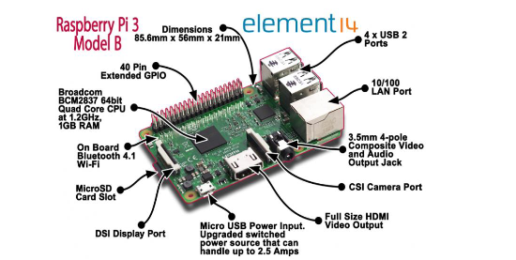

Raspberry Pi module B

**Components and their uses**

1. Raspberry Pi 3 module B: A low cost, credit-card sized computer that plugs into a computer monitor or TV, and uses a standard keyboard and mouse. It is a capable little device that enables people to explore computing and learn how to program in languages like Scratch and Python.
2. 5MP Raspberry Pi Camera: It has several applications including DSLR camera control, time-lapsing machine, security system and face recognition.
3. Arduino Nano: It is used to produce a clock of precise frequency using constant voltage. It, therefore, provided constant voltage for the LED and microsensor.
4. 1-Channel 5V Relay module:An electrically operated switch that can be turned on or off deciding to let current flow through or not. It is designed to be controlled with low voltages and was used for the light bulb.
5. LED (Red): It allows you to know if the current is passing through the circuit and hence serves as the light source.
6. Jumper wires: used to make connections between items (points) on the breadboard and Arduino's header pins.
7. Light bulb: produces light from electricity to produce enough illumination for the proper functioning of the face recognition system.
8. Breadboard: used to build and test circuits quickly before finalizing any circuit design. It has many holes into which circuit components like ICs and resistors can be inserted.
9. Passive Infrared Sensor (PIR) Micro Motion Sensor AM312: detecting the presence of heat energy (such as energy from LEDs) in confined spaces by measuring infrared light radiating from objects in its field of view.
10. USB cable: to connect computers to peripheral devices (in this case the Arduino board and raspberry pi).

Face Recognition technology has improved drastically in the past decade and now it is primarily used for surveillance and security purpose. This project is based on how to build the Face Recognition system using Raspberry Pi. This project consists of three phases:

1. Data Gathering

2. Tracing the recognizer

3. Face Recognition

One major issue involved in the use of the raspberry pi system for facial recognition is the varying lighting condition which majorly affects its ability for facial recognition. Hence, using an Arduino Nano micro sensor powered light bulb, a strong light source is strategically provided for an effective facial recognition system.

**Arduino setup involving the light bulb and microsensor**

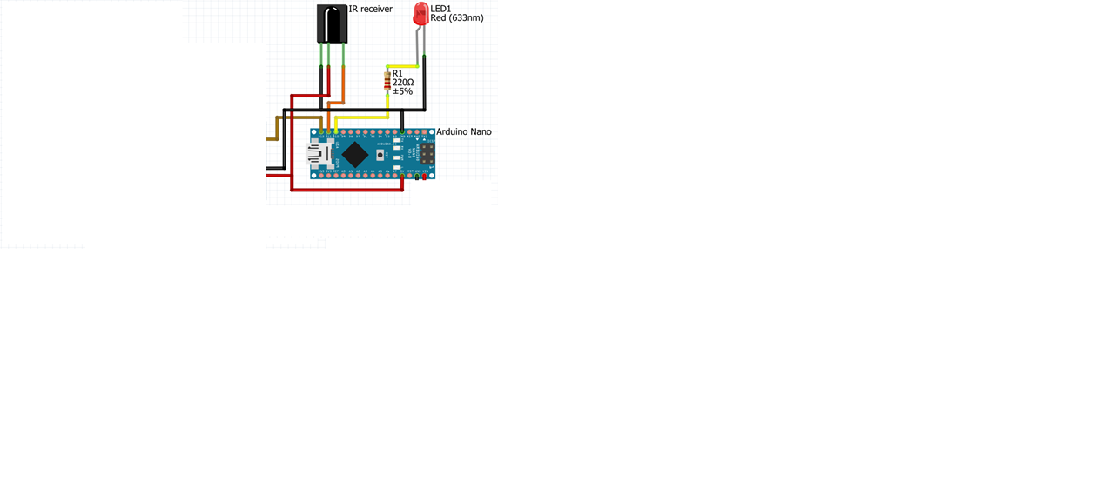

**Procedure**

1. Connect pin 7 of the Arduino Nano to IN 1 of the relay module.
2. Connect the 5v port of the Arduino to the VCC of the relay module.
3. GND of the Arduino Nano is connected to the GND of the relay module
4. We are using the Normally open connection in the relay. so that we can trigger on and off the light.
5. The code is then written in Arduino as shown below

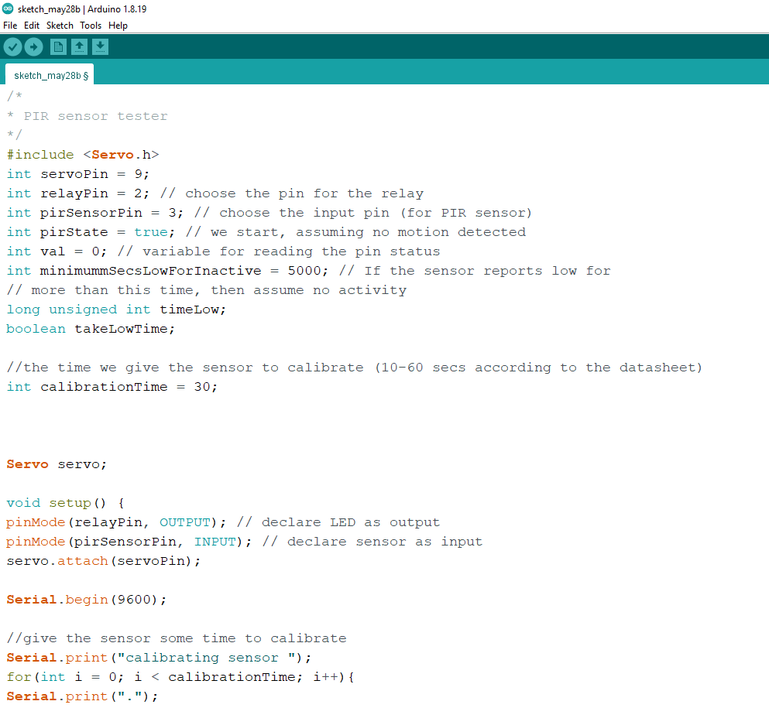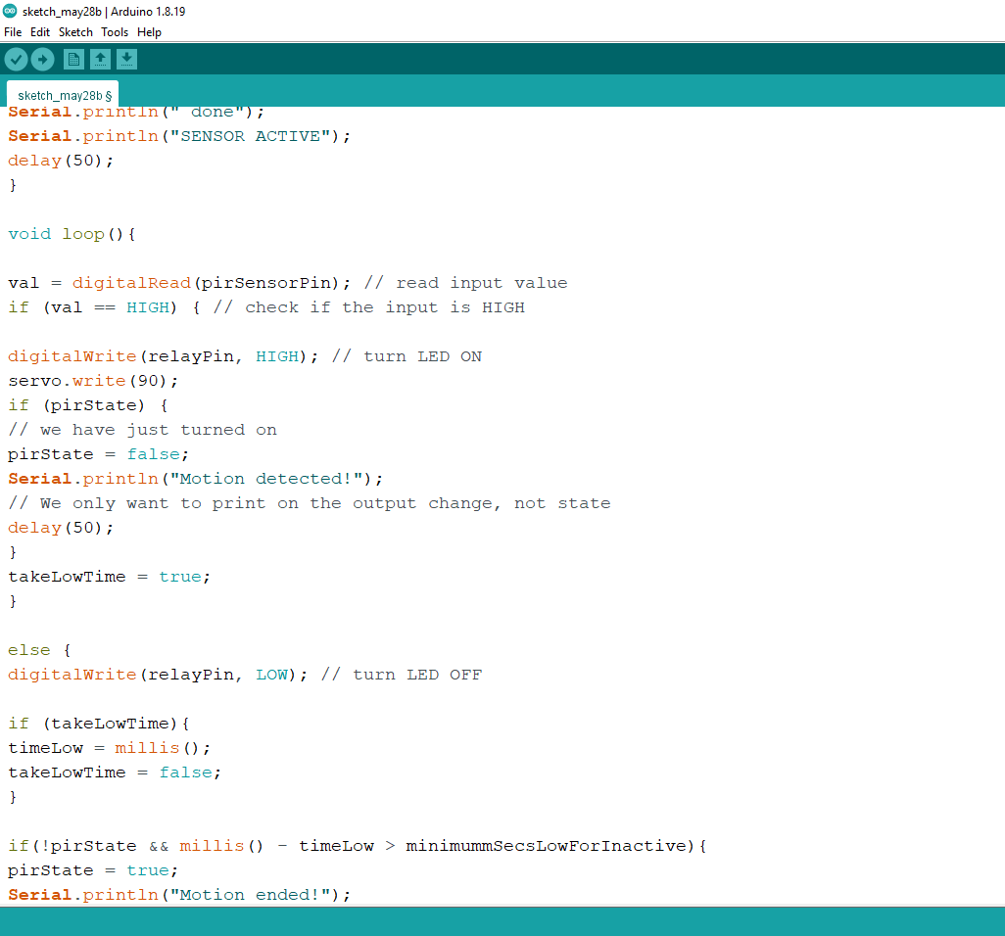

Code for Arduino

**Results**

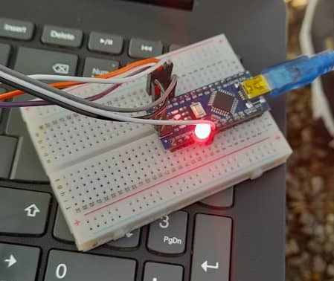

Lighting of LED using the micro motion sensor

**Raspberry pi setup for final recognition**

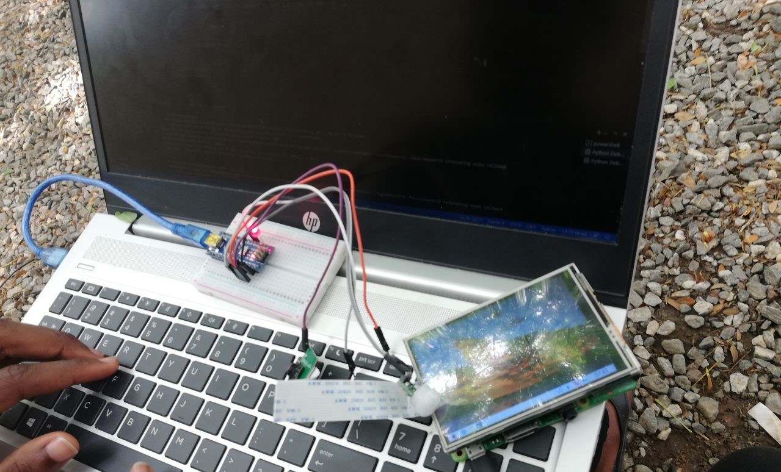

**Project Procedure**

1. Connect the components as shown in the block diagram
2. Download and install the Python software on the computer.
3. Open the python software and copy the codes from the file.
4. After running the program, register the image of the user (Evans Acheampong)
5. After successfully registering the image of the user, turn on the switch and let the system scan the user’s face (Evans Acheampong).
6. After successfully authenticating the user, the system recognizes the specific user’s face and name.

**Results**

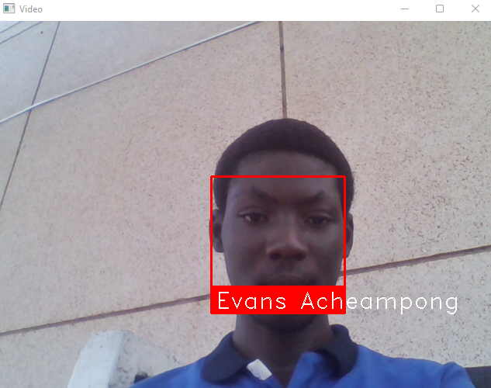

**Conclusion**

In conclusion, in our research, after preprocessing the input face images using some advanced [image processing techniques](https://www.sciencedirect.com/topics/computer-science/image-processing-technique) such as Contrast Adjustment through improving the lighting system, so as to have better image features and the same advanced image processing techniques will be applied to the training/template face images plus an image blending method to ensure high-quality training/template face images. Hence the raspberry pi camera successfully made out my face and name (Evans Acheampong) with the immense help of illumination emanating from the Arduino setup. This effective system has numerous applications such as a facial recognition door system to effectively maintain high levels of security.

**REFERENCES**

[1]<https://iotdesignpro.com/projects/face-recognition-door-lock-system-using-raspberry-pi>

[2]<https://makersportal.com/blog/2020/3/14/arduino-servo-motor-control>(26 May 2020) Use of servo motor.

[3][https://www.sciencedirect.com/science/article/pii/S2590005619300141](https://www.sciencedirect.com/science/article/pii/S2590005619300141%20) (March 5, 2020) Conclusion of the project.

[4]<https://www.instructables.com/Controlling-AC-light-using-Arduino-with-relay-modu/> (20 May 2016)

[5]<https://thesolaruniverse.wordpress.com/2020/10/12/arduino-combined-with-a-switching-relay/> (11 October 2020) Images for the Arduino project

[6]<https://commons.lib.niu.edu/bitstream/handle/10843/21540/Vemulapalli_niu_0162M_13144.pdf;jsessionid=561586E9673ED518E89F80779E42CB2E?sequence=1> (5 June 2018) Image for the raspberry pi 3 model B+

[7] <https://www.sciencedirect.com/science/article/pii/S2590005619300141> (4 March 2020) Abstract of the project.

[8] <https://www.ijcaonline.org/archives/volume176/number33/dass-2020-ijca-920387.pdf> (June 2020) Introduction to the facial recognition.